Booking Enquiry Form
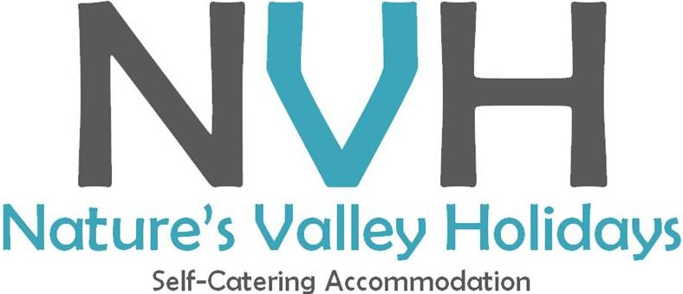
Please complete and submit the following form

Minimum stay of:
7 Nights: High Season (15 Nov – 15 Jan)
5 Nights: Easter School Holiday Season
3 Nights: Rest of the Year
HOUSE NAME/REFERENCE #  Reference as per website | Click here to enter text.
ALTERNATIVES  Alternative house references should your first choice not be available | Click here to enter text.
First Name* | Click here to enter text.
Last Name (Surname)* | Click here to enter text.
Email Address* | Click here to enter text.
Mobile / Cell Number* | Click here to enter text.
Alternative Number | Click here to enter text.
Residential Address | Click here to enter text.
Nationality* | Click here to enter text.
ID/Passport Number* | Click here to enter text.
Arrival Date* (Check-in strictly after 14H00) | Selection per calendar date
Departure Date (Checkout strictly before 10H00) | Selection per calendar date
Number of Adults* | Drop-down selection
Number of Couples / Double Rooms Needed* | Drop-down selection
Ages of Children (e.g. 1,3,6, 12…) | Click here to enter text.
Nu. of Pets - if permitted (Only dogs allowed - charged at R250 per dog per booking) | Drop-down selection
Cleaning Days (Charged at R350 per cleaner per day). Depending on availability, cleaning staff during your stay can be arranged | Drop-down selection
Preferred Language | Drop-down selection (Afrikaans, English)
Special Requests/Notes | Click here to enter text.
Booking procedures and fees:
- Reservations should be made in writing and will be confirmed in writing
- You will be contacted within the next 5 working days to discuss availability
- 50% of the booking fee is to be paid in advance to confirm your booking
- Full pre-payment of the balance of total services booked, including a compulsory R1850 Key, Cleaning and Breakage deposit* is required no later than 14 working days prior to your arrival date. Non-payment of the balance by this date will result in a 50% cancellation charge.
- *The Key, Cleaning and Breakage deposit is refundable after the house has been scrutinised and all found in order. For reservation departures up to the 15th of the month, the deposit will be refunded at month-end into your bank account. For reservation departures after the 15th of the month, the refund will be carried over to the following month-end. Keys will not be handed over without the deposit having been received. For more detail, please refer to our Booking Terms and Conditions per our website and attached to your invoice.
- Payment can be made by direct bank deposit (EFT) as per invoice
- No check-ins or check-outs are offered on Good Friday, Christmas Day or New Year's Day
- Cancellations will attract the following charges (All exclude the Key, Cleaning and Breakage Deposit as well as extras paid in advance, for instance cleaning etc.):
- 100% cancellation charge for total services reserved if cancelled 6 or fewer days in advance; (this includes all ‘no-shows’ – non arrivals without written cancellation)
- 75% cancellation charge for total services reserved if cancelled between 7 and 14 days prior to arrival
- 50% cancellation charge as outlined above if cancelled between 15 and 21 days prior to arrival
- 25% cancellation charge as outlined above if cancelled between 22 and 30 days prior to arrival
- 0% cancellation charge if cancelled 31 or more days prior to arrival

SUBMIT

Na die “Submit’ knoppie gedruk is, moet die volgende boodskap op die skerm verskyn:

Thank you for your enquiry with Nature’s Valley Holidays (NVH). We will contact you within the next 5 working days to discuss availability and alternative accommodation options should your first choice not be available. In the meanwhile, we have sent you an email summarising the booking terms, conditions and procedures.

Die Email (onder) moet dan automaties uitgestuur word na {Email Address}:

Dear {Name}

RE: {House name/Reference #}

Banner across with logo

Thank you for your booking enquiry. We are excited to help you find the accommodation you need in order to make your stay in Nature’s Valley as comfortable and enjoyable as possible.

We need some time to confirm availability with the owners and therefore will contact you within the next 5 working days to discuss availability and alternative accommodation options should your first choice not be available. Should you need accommodation before then, please contact me directly on my cell phone (see number below).

In the meantime, please take time to go through the following summary of the booking terms, conditions and procedures that will also accompany your invoice:

Booking Procedures and fees:

- Reservations should be made in writing and will be confirmed in writing
- You will be contacted within the next 5 working days to discuss availability
- 50% of the booking fee is to be paid in advance to confirm your booking
- Full pre-payment of the balance of total services booked, including a compulsory R1850 Key, Cleaning and Breakage deposit* is required no later than 14 working days prior to your arrival date. Non-payment of the balance by this date will result in a 50% cancellation charge.
- Payment can be made by direct bank deposit (EFT) as per invoice

*The Key, Cleaning and Breakage Deposit is refundable after the house has been scrutinised and all found in order. For reservation departures up to the 15th of the month, the deposit will be refunded at month-end into your bank account. For reservation departures after the 15th of the month, the refund will be carried over to the following month-end. Keys will not be handed over without the deposit having been received. For more detail, please refer to our Booking Terms and Conditions per our website and attached to your invoice.

Minimum stay:

- During High Season (15 Nov – 15 Jan) a minimum stay of 7 nights is required
- During the Easter School Holiday Season a minimum stay of 5 nights is required
- During the rest of the year a minimum stay of 3 nights is required

Cancellation Policy:

Cancellations will attract the following charges (All exclude the Key, Cleaning and Breakage Deposit as well as extras paid in advance, for instance cleaning etc.):
- 100% cancellation charge for total services reserved if cancelled 6 or fewer days in advance; (this includes all ‘no-shows’ – non arrivals without written cancellation)
- 75% cancellation charge for total services reserved if cancelled between 7 and 14 days prior to arrival
- 50% cancellation charge as outlined above if cancelled between 15 and 21 days prior to arrival
- 25% cancellation charge as outlined above if cancelled between 22 and 30 days prior to arrival
- 0% cancellation charge if cancelled 31 or more days prior to arrival

Check-In and Checkout:

- Check-in time is strictly from 14h00 onward.
- Check-out time is strictly at 10h00 on the last day of your stay. Please make sure the house is locked, windows closed and air cons off when departing. Any house that is not vacated by 10h00 will be subject to a surcharge of R200 per hour or part thereof, for each hour exceeding the check-out time. This surcharge will automatically be deducted from the Key, Cleaning and Breakage deposit.

No check-ins or check-outs are offered on Good Friday, Christmas Day or New Year's Day

Pets:

Strictly no pets are allowed in any house not specifically identified as pet friendly when you make your booking. Our pet friendly houses only alllow dogs and is charged at R250 per dog per booking. No cats or any other pets that might be harmful to the surrounding wildlife are permitted.

General:

Please note that all our rental houses are Self-Catering; therefore we ONLY provide a starter kit that consists of the following:
- Small amount of dishwashing liquid and/or 2 dishwasher blocks
- One kitchen cloth an one dish towel
- Two rubbish bin bags
- Toilet paper – 1 roll per bathroom
- Couple of candles and matches
- Small amount of salt and pepper
- A small bundle of wood and firelighters
- Coffee, milk and sugar – just enough to get you going for that first day/night

We do not provide swimming / beach towels. Towels in the houses are only to be used for bathing / showering.

In addition to the above bring along your own toiletries, food & drinks.

Lastly, please note Nature’s Valley Holidays is not registered with the Estate Agency Affairs Board (EAAB) as a Letting Agent. We are a well-established private self-catering accommodation rental service provider who resides in Nature’s Valley.

I look forward to confirm availability within the following 5 working days.

Kind Regards,

Signature and logo asb Theresa

